**SETUP OF NOTEPAD AND MINGW**

***LAB 3 TASK***

**Fizza Batool {24K-0587}**

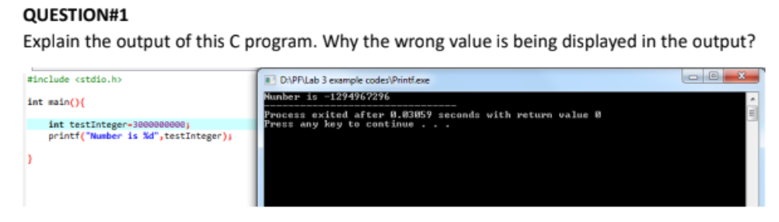

**ans)** int datatype has only 4 bytes memory so as a result of storing a larger number than that, it turns negative due to two's complement form.

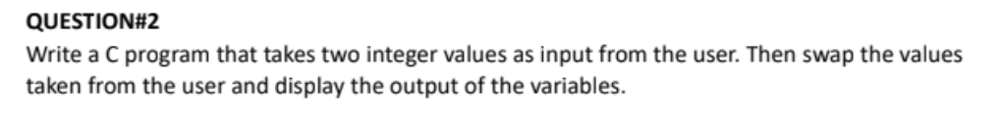

#include <stdio.h>

int main()

{

int a = 5;

int b = 10;

int c;

printf("before swapping\n a = %d\n b = %d\n", a, b);

c = a;

a = b;

b = c;

printf("after swapping\n a = %d\n b = %d\n", a, b);

}

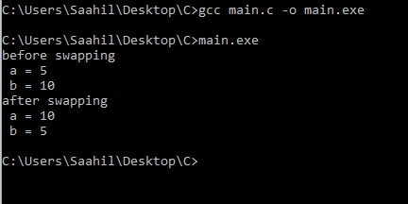

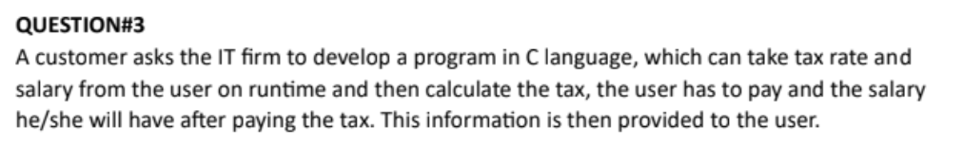

#include <stdio.h>

int main()

{

int taxrate, salary;

printf("enter taxrate:");

scanf("%d", & taxrate);

printf("enter salary: ");

scanf("%d", & salary);

float tax = (taxrate*salary)/100;

float Fsalary = (salary - tax);

printf("your tax is %.1f\n your salary is %.1f", tax, Fsalary);

}

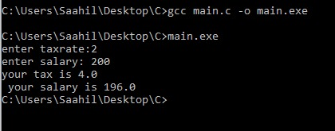

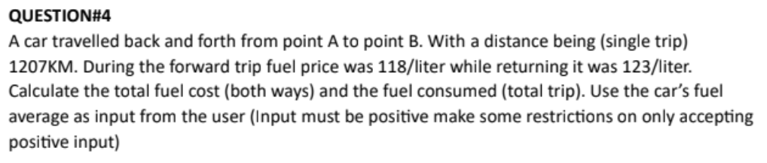

#include <stdio.h>

int main()

{

int avg;

int dis = 1207;

int Ffuelprice = 118;

int Bfuelprice= 123;

printf("enter car's fuel average: ");

scanf("%d", &avg);

float fuelrequired = dis/avg;

float totalcost = fuelrequired*Ffuelprice + fuelrequired*Bfuelprice;

printf("you need %.f of fuel\n your cost is %.f", fuelrequired*2, totalcost);

}

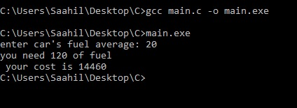

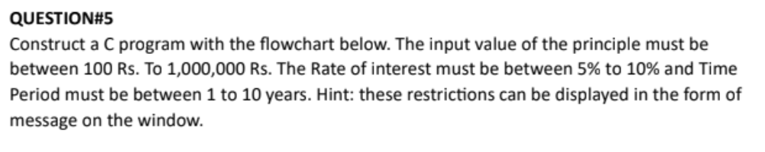

#include <stdio.h>

int main()

{

long int P;

float R;

int T;

printf("enter P between 100 and 1000000 : ");

scanf("%li", &P);

while (!(P >= 100 && P <= 1000000))

{

printf("enter P again: ");

scanf("%li", &P);

}

printf("enter R between 5 and 10 % : ");

scanf("%f", &R);

while (!(R >= 5 && R <= 10))

{

printf("enter R again: ");

scanf("%f", &R);

}

printf("enter T between 1 and 10 years: ");

scanf("%d", &T);

while (!(T >= 1 && T <= 10))

{

printf("enter T again: ");

scanf("%d", &T);

}

float Interest = (P*R*T)/100;

printf("your Interest is: %f", Interest);

}

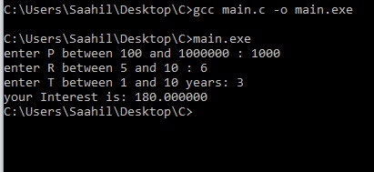

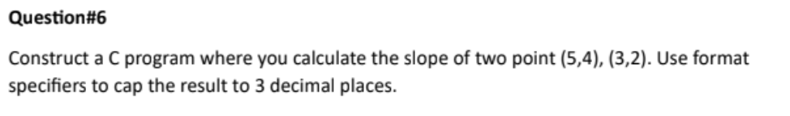

#include <stdio.h>

int main()

{

int x1, y1, x2, y2;

printf("enter x1: ");

scanf("%d", & x1);

printf("enter y1 : ");

scanf("%d", & y1);

printf("enter x2: ");

scanf("%d", & x2);

printf("enter y2 : ");

scanf("%d", & y2);

float gradient = (y2-y1)/(x2-x1);

printf("gradient = %.f", gradient);

}

